Lab 10
- Introduction
In modern operating systems, processes often access data stored in memory in units called pages. When a process tries to access a page that is not currently in memory, a page fault occurs. Handling page faults efficiently is critical because excessive page faults can significantly slow down system performance.
When the physical memory is full, the operating system must decide which page to remove to make space for the new one. This decision is handled by page replacement algorithms.
Two widely used page replacement strategies are:
- FIFO (First-In-First-Out):
  - This strategy evicts the page that has been in memory the longest, regardless of whether it has been used recently.
- LRU (Least Recently Used):
  - This strategy evicts the page that has not been used for the longest time, taking into account the actual usage pattern of pages.
The goal of this lab exercise is to implement the LRU algorithm, simulate both FIFO and LRU on the same workload, and analyze their performance by comparing the total number of page faults.
2. Algorithm Explanations
2.1 FIFO (First-In-First-Out)
- Memory is treated as a queue.
- When a page fault occurs:
  - If memory is not full → add page to the end.
  - If memory is full → remove the front page (the oldest).
- Simple but does not consider usage patterns.
- Can cause Belady’s anomaly (more frames → more page faults in some cases).
2.2 LRU (Least Recently Used)
- Memory maintains a list of recency.
- Each page access:
  - If page is in memory → move it to the most recent end.
  - If page fault occurs:
    - If memory has space → add page at MRU end.
    - If memory full → remove least recently used page (front) and insert new page at MRU end.
- Models temporal locality of processes (recently used pages are likely to be used again).
- Usually performs better than FIFO for real workloads.
FIFO:
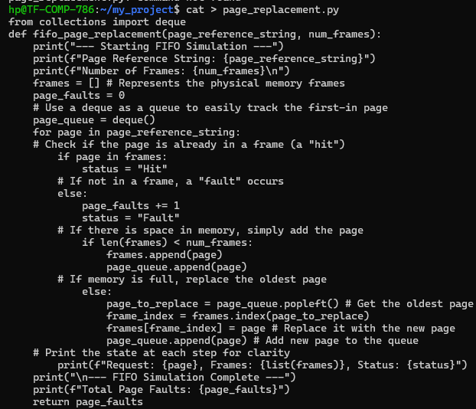
LRU:
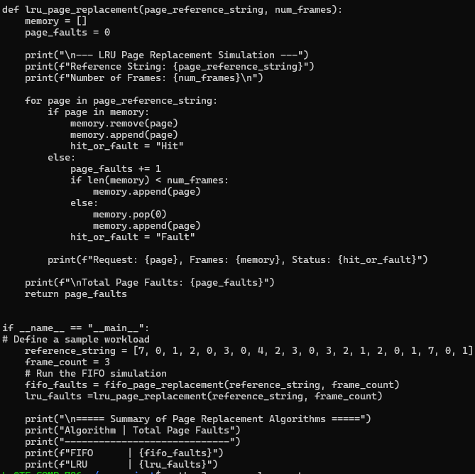
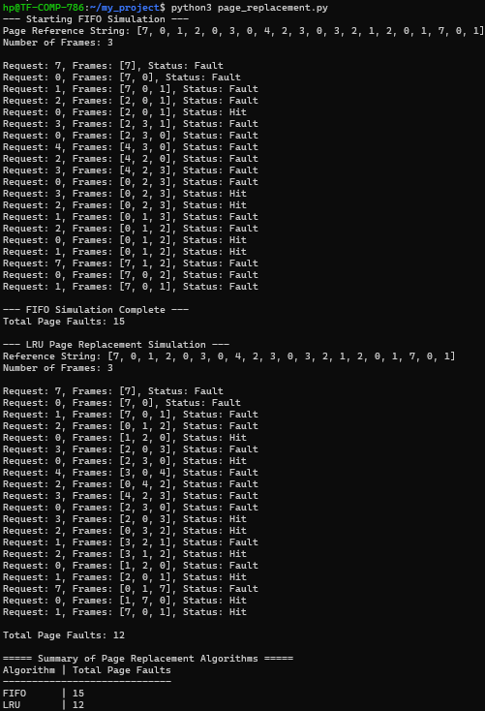
Which algorithm performed better?
- In this simulation, LRU performed better than FIFO, producing fewer page faults.
- The reason is that LRU keeps recently used pages in memory, reducing the chance of removing a page that will be needed again soon.
Why this difference occurs
- FIFO only considers the arrival order of pages, not how frequently or recently they are accessed.
- LRU accounts for recency of use, meaning pages that are being actively used stay in memory longer.
This simple change significantly reduces unnecessary evictions in workloads with temporal locality.

